Send to: sps-vg@inrae.fr

Events / Guests | 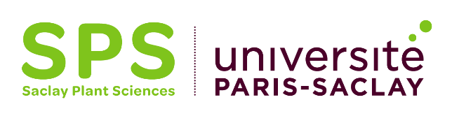

(2 pages maximum)
ATTENTION:

> You can fill the “Event” part OR the “Guest” part of this form but not both!
If the budget you request for an event includes transportation fees for a speaker, you must precise it in the “justification” section of the “Event” part of this form.

> In order to reduce greenhouse gas emissions:
- SPS will not fund air travel for SPS members
- SPS strongly encourages SPS guests not to travel by airplanes
if the duration of the alternative journey by train is less than 8 hours for a one-way trip.
Any exceptional case must be justified and will be considered. In case of a long trip (> 6h), SPS can cover an extra hotel night if necessary.

Contact:
Name:
Institution and Laboratory:
Email address:

Event
Attention:
Concerning the funding of symposia, only the international symposia, for which the conferences are given in English, will be examined.

Nature of the event:

Dates and duration of the event:

Estimation of the total budget of the event (and contribution of the different funding institutions):

Requested budget (1000 euros max): €
Justification:

Guest
The guest will have to present a public seminar and, during his / her visit, time must be devoted to discussions with the SPS members who might be interested.
The benefit of the guest’s visit and seminar for the whole SPS community will be taken into account in the SPS decision to participate or not in the travel expenses.
Attention:
If the person is invited for educational purposes and teaches in any form whatsoever, you must fill the “Education” funding form instead of this one.

Name of the guest:

Dates and duration:

Estimation of the total budget of the visit (please detail) and contribution of the different funding institutions:

Requested budget (1000 euros max): €
This financial contribution will be used for:

Name of the teams interested in interacting with the guest or justification of the high interest of the seminar for the SPS community:
Resume of the guest:

